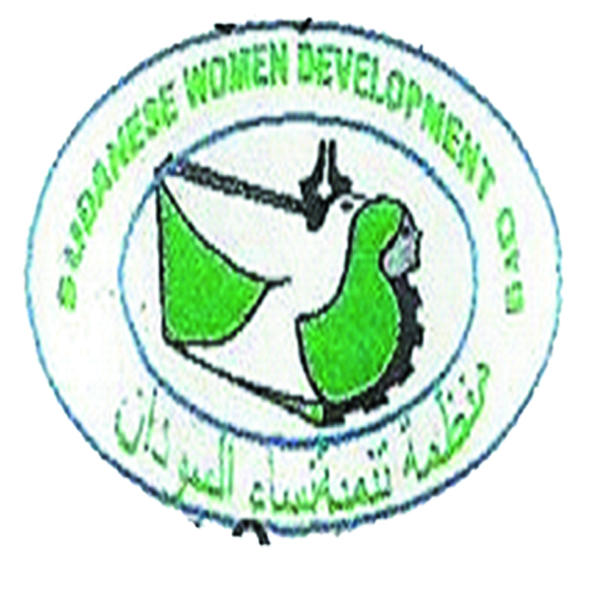

**South Darfur State**

**Sudanese Women Development Organization**

**Organization Profile**

**Organization Background:**

Sudanese Women Development Organization (SWDO) is a national NGO which was registered in 2008 at humanitarian aid commission (HAC) South State currently has valid registration of 2022. Our registration certificate is normally renewed every year. Sudan Women Development basically a humanitarian organization whose vision is to promote peace and protection for women , Human right legal aid among the community , Development and Community Empowerment for All among the different communities of South Darfur State.

(SWDO) has been able to develop good relationship with local communities particularly IDPs, host community, refugees and rural areas, nomadic group and past lost. This will enable it to implement future activities smoothly.

In addition the organization has competent and experienced staff as well as well-equipped coordination office in Nyala .

In Darfur, women are part of the solution to hunger and poverty and they are the gate to development. Therefore .that SWDO concentrate on women capacity building in different livelihood activities. So sustainable growth can only occur when everyone – women, men and children – are involved. SWDO works with both women and men to improve the cultural. Social and economic

Participation of women and girls in their communities, in word, SWDO considers gender equity in its planning and operation.

**Our vision**

* SWDO vision is a Sudan of hope with empowered community and social justice, where poverty and illiteracy
* To work towards and Leadership, excellence and voluntary action in Sudan.

Now we are at the onset of another to rebuild human dignity that are affected by war or natural disaster The peace building process for this vision of community peace link them peacefully through community capacity building enhancement approaches through three dimension of community change (peace and stability, women enhancement governance, improvement social basic services.

**Our value**

We are SWDO respect human dignity, transparency, openness towards core humanitarian standards and multi-cultural respect over humanity, support psychosocial of human rights principles, Dependability, Reliability, Commitment, Open-mindedness, Consistency, Efficiency, Honesty on implementation , Innovation new things by own staff , sustain capacity building in Human rights .

**Our Mission**

To Positive change in the lives of orphans, widows and poor women, with support for homeless and separated families and children in the region of Sudan Darfur region.

Darfur women from foster or adoption to self-reliance

Supports women community whom are affected in conflict, our mission is unique role play in advancing intergovernmental coherence through its cross-pillar or cross cutting issues of peace mandate, has already diversified its working methods to enhance its flexibility as a dedicated intergovernmental platform

**THE Objective:**

Ensuring orphans and widowed mothers in the Sudan and Africa Protecting children from homelessness and loss.

Increase income and improve the standard of living of poor families.

The mobilization of the community to contribute to the work of benevolence.

Raising community awareness to understand women's and children's issues, and rule of law, and peace building issues addressed

Support Women Community awareness and the following are the rights of the child's duties and the woman, Children in difficult circumstances/ cases and awareness of the dangers of AIDS, harmful habits, health and nutrition. protection,

* Reduced to the minimum and people live in dignity and security without discrimination.

SWDO believes in contributing towards Peace, development and community Empowerment for all by undertaking innovative initiatives in the following sectors in South Darfur state:

* Peace Building ,
* Gender and protection ,
* Education.
* Food security and livelihoods activities FSL
* Capacity Building.
* Health / Hygiene promotion

**STRATEGIC SECTORS OF THE ORGANIZATION**

The organization works in the following sectors.

* Peace Building ,
* Gender and protection ,
* Education ,
* Food security and livelihoods ,
* Capacity Building ,
* Environment protection ,
* Health / hygiene promotion.

**ORGANIZTION GEOGRAPHICAL AREAS OF OPERATION.**

* Nyala Locality
* Shangelitubaya
* Kass Locality.
* Alsalam locality .h
* Beleil locality.
* Mershing Locality
* Gereida locality.
* Alsonta Locality.
* Buram Locality.
* East Jabal Marra locality

**CORPERATION AND CORPERATION.**

SWDO normally coordinates our activities with ministry of social affairs , ministry of forest , ministry of education , HAC , community leaders ,UN Agencies and other nongovernmental organization operating in the same area to avoid duplication of services . Partnership is usually formalized by endorsing a technical agreements with stakeholders of which we have the copies .attending all meetings organized by them , we also submit reports of our activities I,e weekly monthly quarterly reports ., assessment and at the of end of the project etc. .

We also attended weekly NGOs and UN agency coordination meetings organized in OCHA periodically meeting and HAC meeting as well .

**ORGANIZATION FUCOSSING PROJECTS**

SWDO is fully committed to its mission that is realistic if supported by all

Stakeholders in this conflict and this serves as a guiding principle to all SWDO

Initiatives in rural as well as urban locations.

SWDO for the development of Women adopted his post by the office of humanitarian work based on the rules and laws of national organization in 2014 to build the capacity of rural women.

SWDO plan the following program for future.

* Develop three years strategic plan considering education.
* Livelihoods for rural communities, peace –building and development.
* Advocating for legal reform and / the implementation of current legislation to address structural causes of different forms of GBV.
* Developing targeted strategies to address GBV specially excluded and underserved groups of women.
* Providing direct services for victims of GBV (access to justice, legal aid. psychosocial support, medical and health services) .
* .address GBV.

**South Darfur State.**

Darfur is located in the west of Sudan .It has witness brutal fighting that forced more than 2.5 million people to flee their homes since 2003. Civil war in Darfur region has witness a wave of violence and terror against countless citizen .Building our support for victims of other civil conflicts in war –torn.

Sudan spanning nearly three decades .we support peace –buildings. Education .NFI. And Emergency shelter, food security. And hoods. Protection for the most venerable groups in Darfur

The context for providing humanitarian assistant in Darfur has gradually improved in 2011 .The improvement in security, the enhanced government relation with armed movement...the efforts to integrating IDPs camps to operation areas and the increased desire to IDPs to return to their places of origin has placed shift in humanitarian assistance response.

**The Implemented activities.**

SWDO established as local organization focusing on community development. Below are some examples of implemented projects:

Capacity –building support to service providers working to address GBV.

TOT workshop on Sexual –Based Violence in partnership with UNFPA –April 2009.

Workshop on women roles in peace –building in 2014 Aug .the participants were 25 women from different camps around Nyala.

In April 2015 SWDO organized workshop in legal aid with partnership with International Bar Association.

Distribution of garments for Hujair Tuno with UNFPA IDPs women partnerships with UNFPA on Jan 2016

Distribution of hygiene Kits for Higair Tuno IDPs with UNFPA.

Child protection in local and international laws. With UNCEF in 2016 March for 50 participants (men and women) at legislative council.

Partnership with MC international executing peace building project in Asalam and Beleil localities (13 villages) returnees established committees for women and men and trained them on peace building issues in July 2018.

**Organization contact Address**

Sudanese Women Development Organization (SWDO)

South Darfur - Nyala -Almazad block

Nyala City –South Darfur state

TELL Tel: 0912574729-- Tel: 0115948180

Email: [Swdo2020@gmail.com](mailto:Swdo2020@gmail.com)